|  |  |
| --- | --- |
| **FUNCTIONAL APPROVAL SHEET** | |
| Client Name | PT Astra International Tbk |
| Application Name | Mobile FS – Dashboard CMS |
| Function Name | Dashboard – CMS Mobile FS |
| Menu in Application | Report |
| Version | 1.0 |

# Main Success Scenario: Report

1. **Introduction**
2. This is a new submenu in version v.1.0.
3. This page can be accessed by Admin (Area Leader).
4. This page is used to view and generate report by ticket status and user feedback.
5. **Navigate to Form**
6. To load this form, User must access ‘(link CMS)’, log in to the application, then select ’Report’ as shown below:

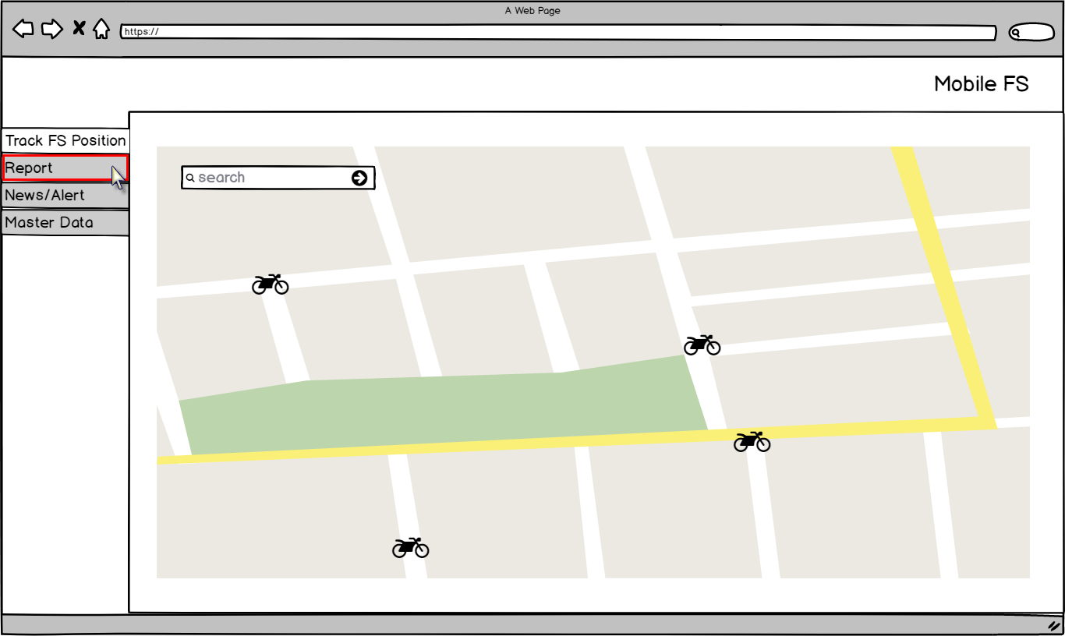

Figure – Navigation to ‘Report’ – Mobile FS

1. Application will load following page:

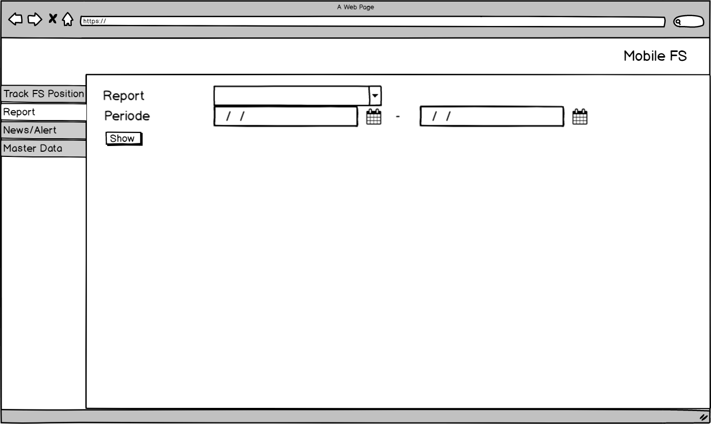

Figure – ‘Report’ Page – Mobile FS

**Condition [Figure 2]:**

* When initially loaded, application will enable following attributes:
* ‘Report’ combo box.
* ‘From’ date time picker.
* ‘To’ date time picker.
* ‘Show’ button.

1. **Function Provided in Form**

In this form, User can view and generate data to excel for Ticket Status and User Feedback.

### Report – Ticket Status

#### View Report – Ticket Status

To view and generate these reports, Admin must do following steps:

1. Clicks ‘Report’ combo box and selects ‘Ticket Status’:



Figure – Report Options - Report

**Note:**

* This is a mandatory field.

1. Selects period ‘From’ as the start date and ‘To’ as the end date of the report that will be displayed:

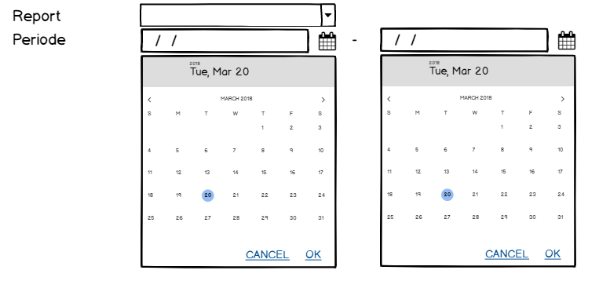

Figure – Date Time Picker – Report

**Note:**

* This is not a mandatory field.
* The start date must be older than the end date.

1. Clicks ‘Show’ button:

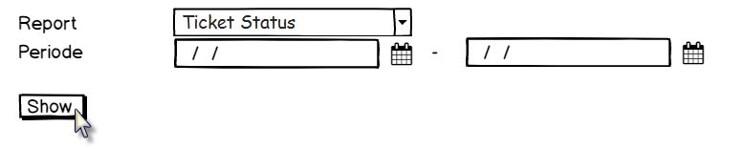

Figure – ‘Show’ Button – Report

1. Application will display data in data grid based on which report that has been selected:

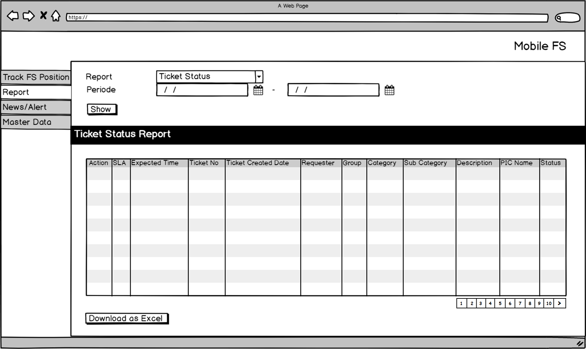

Figure – ‘Ticket Status’ Report – Report

**Condition [Figure 6]:**

* When initially loaded, application will enable following attributes:
* ‘Report’ combo box.
* ‘From’ date time picker.
* ‘To’ date time picker.
* ‘Show’ button.
* ‘Download as Excel’ button.
* Pagination.
* Application will disable data grid. If Admin did not set the period, as default application will display all data.
* Application will display 15 data in data grid. If there is more than 15 data, then Admin must click the next page in pagination.
* If the value in data grid is too long, Admin can see the detail by hovering the mouse on selected field, then application will display the detail as tooltip as shown below:

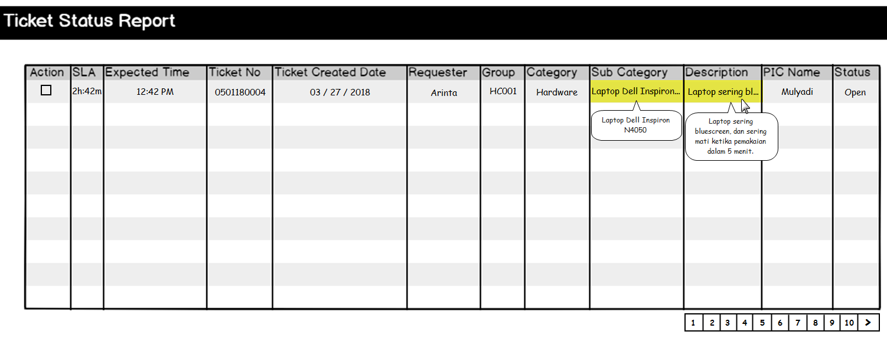

Figure – Tooltip – Report

* Admin can sort data grid by ascending or descending, by clicking the header of the data grid. If Admin did not sort the data, data will be displayed based on last updated data.
* In Report – Ticket Status, application will display all tickets **except** ‘Done’ tickets.
* Data displayed in ‘Report – Ticket Status’ data grid are taken from following tables and columns:

|  |  |  |  |
| --- | --- | --- | --- |
| **COLUMN IN DATA GRID** | **TABLE IN DATABASE** | **COLUMN IN DATABASE** | **DESCRIPTION** |
| SLA |  |  | Standard of time when the ticket should be done. |
| Expected Time |  |  | Estimated time when the FS will finish the ticket. |
| Ticket No |  |  | Ticket number that has been submitted by requester. |
| Ticket Created Date |  |  | Date of ticket that has been submitted by requester. |
| Requester |  |  | Name of a person whom submit the ticket if the requester is AD. |
|  |  | Name of a person whom submit the ticket if the requester is non AD. |
| Group |  |  | Selected group of problem. |
| Category |  |  | Selected category of problem. |
| Sub Category |  |  | Selected sub category of problem. |
| Description |  |  | Description of ticket that has been submitted by requester. |
| PIC Name |  |  | Name of PIC of the ticket at that time.  Example, when the ticket is in ‘Transfer’, then application will display FS’ name who received the ticket transfer. |
| Status |  |  | Status of the ticket at that time.  Example, ‘Transfer’. |

#### Download Report – Ticket Status

To download the report, Admin must do following steps:

* 1. Admin clicks ‘Download as Excel’ button.

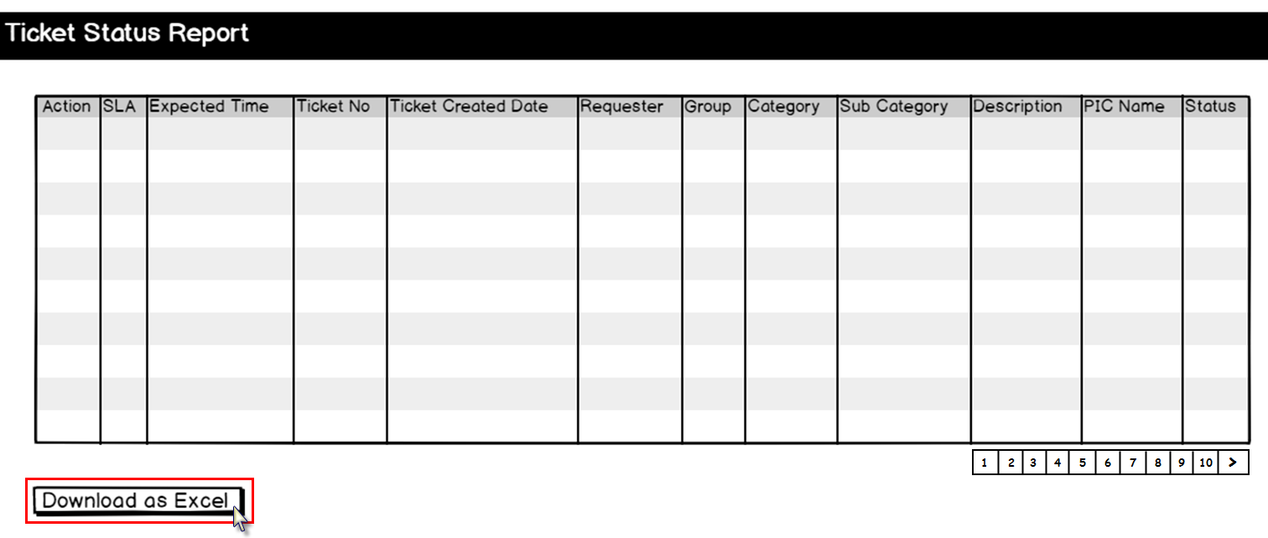

Figure – ‘Download as Excel’ Button – Report

* 1. Application will display a pop up browse dialog to save the excel file:

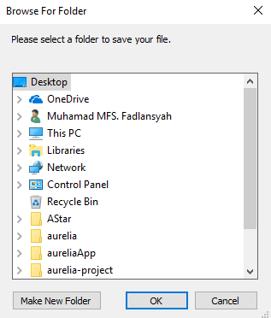

Figure – Browse Dialog – Report

* 1. The file will be saved in selected folder.

### Report – User Feedbacks

#### View Report – User Feedbacks

To view and generate these reports, Admin must do following steps:

* + 1. Clicks ‘Report’ combo box and selects ‘User Feedback’:



Figure – Report Options – Report

**Note:**

* This is a mandatory field.
  + 1. Selects period ‘From’ as the start date and ‘To’ as the end date:



Figure – Date Time Picker – Report

**Note:**

* This is not a mandatory field.
* The start date must be older than the end date.
  + 1. Clicks ‘Show’ button:



Figure – ‘Show’ Button – Report

* + 1. Application will display data in data grid based on which report that has been selected:

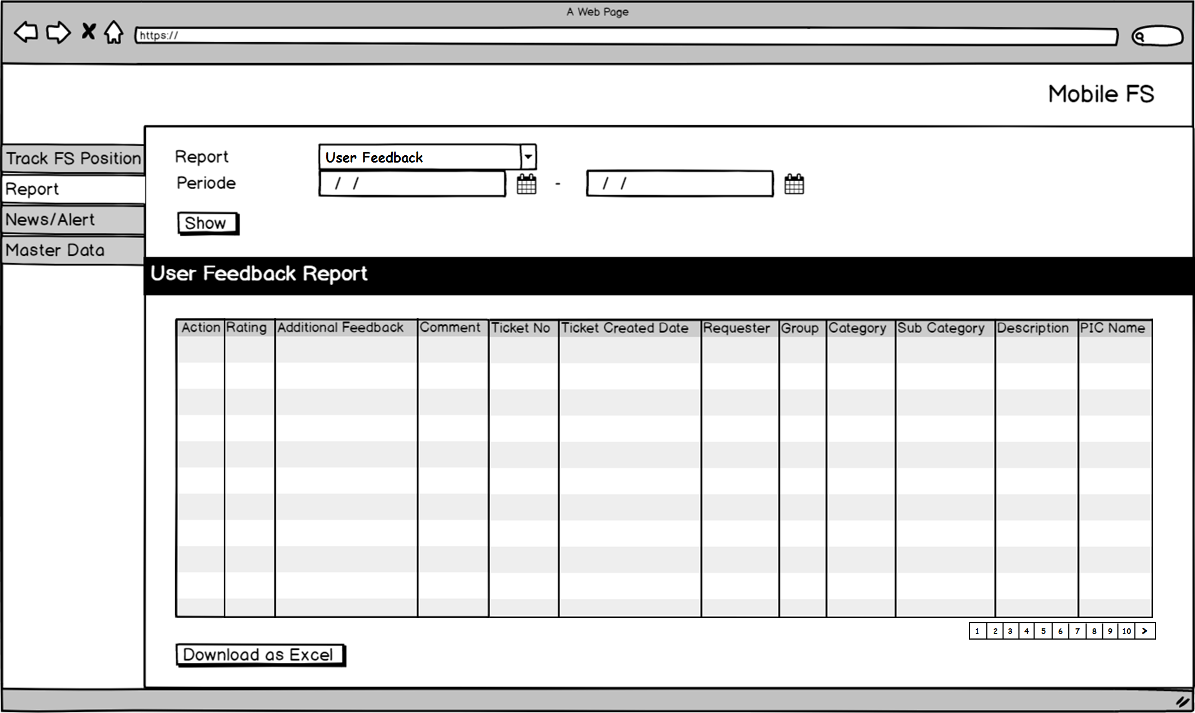

Figure – ‘User Feedback’ Report – Report

**Condition [Figure 12]:**

* When initially loaded, application will enable following attributes:
* ‘Report’ combo box.
* ‘From’ date time picker.
* ‘To’ date time picker.
* ‘Show’ button.
* ‘Download as Excel’ button.
* Pagination.
* Application will disable data grid. If Admin did not set the period, as default application will display all data.
* Application will display 15 data in data grid. If there is more than 15 data, then Admin must click the next page in pagination.
* If the value in data grid is too long, Admin can see the detail by hovering the mouse on selected field, then application will display the detail as tooltip as shown below:

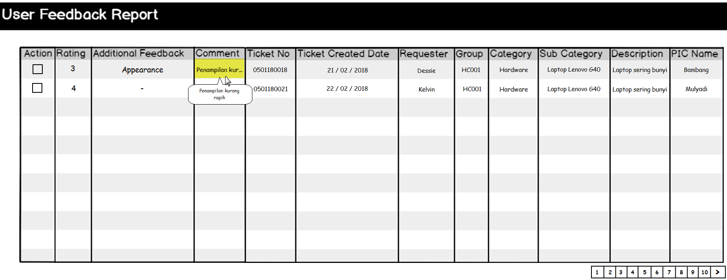

Figure – Tooltip - Report

* Admin can sort data grid by ascending or descending, by clicking the header of the data grid. If Admin did not sort the data, data will be displayed based on last updated data.
* In Report – User Feedback, application will display **all tickets that has been ‘done’**.
* Data displayed in ‘Report – User Feedback’ data grid are taken from following tables and columns:

|  |  |  |  |
| --- | --- | --- | --- |
| **COLUMN IN DATA GRID** | **TABLE IN DATABASE** | **COLUMN IN DATABASE** | **DESCRIPTION** |
| Rating |  |  | Rate (stars) that has been given to FS by requester.  Rating will be shown in numeric. |
| Additional Feedback |  |  | Scoring options that has been given to FS by requester. |
| Comment |  |  | Comment(s) that has been given to FS by requester. |
| Ticket No |  |  | Ticket number that has been submitted by requester. |
| Ticket Created Date |  |  | Date of ticket that has been submitted by requester. |
| Requester |  |  | Name of a person whom submit the ticket if the requester is AD. |
|  |  | Name of a person whom submit the ticket if the requester is non AD. |
| Group |  |  | Selected group of problem. |
| Category |  |  | Selected category of problem. |
| Sub Category |  |  | Selected sub category of problem. |
| Description |  |  | Description of ticket that has been submitted by requester. |
| PIC Name |  |  | Name of PIC of the ticket at that time.  Example, when the ticket is in ‘Transfer’, then application will display FS’ name who received the ticket transfer. |

#### Download Report – User Feedbacks

To download the report, Admin must do following steps:

* + 1. Admin clicks ‘Download as Excel’ button:

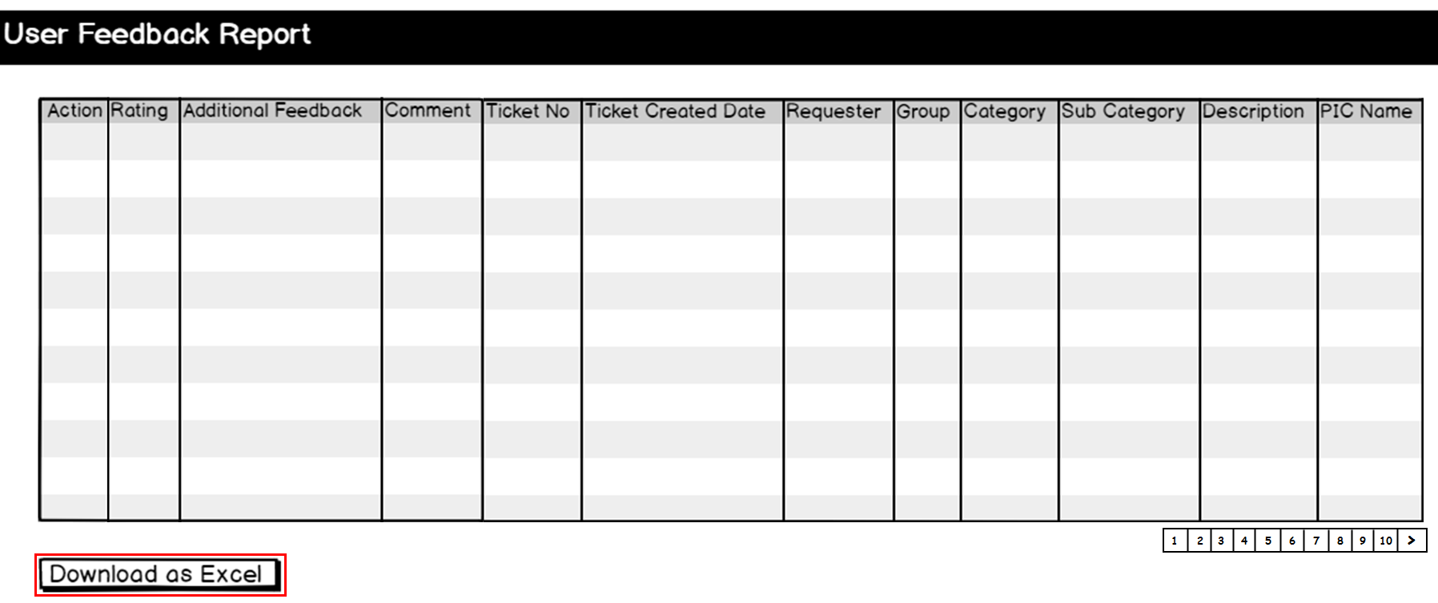

Figure – ‘Download as Excel’ Button – Report

* + 1. Application will display a pop up browse dialog to save the excel file:



Figure – Browse Dialog – Report

* + 1. The file will be saved in selected folder.

# Extension:

When ‘Submit’ button is clicked in ‘Add’ and ‘Edit’ function:

1. If ‘Report’ combo box has not been selected, following message will be shown:

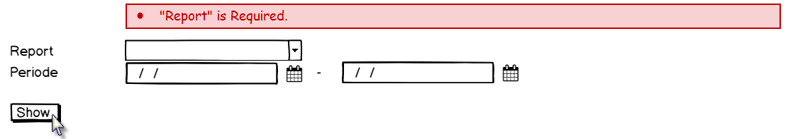

Figure – Error Message – Report

|  |  |  |  |
| --- | --- | --- | --- |
| PREPARED BY | REVIEWED BY | | APPROVED BY |
|  |  |  |  |
| Name: Rizky Fitriandini | Name: Yongkie Saputra | Name: Rahmat Hidayat | Name: Arif |
| Moonlay Business Analyst | Moonlay Project Manager | Product Manager | Project Owner |
| Date: March 20th, 2018 | Date: April 10th, 2018 | Date: | Date: |

Copyright © Moonlay Technologies. All Rights Reserved.